## Title : Pick your favorite design agency. Redesign their contact page in a more user-friendly way.

Procedure :

**Develop the Frontend**

1. **Choose a Technology Stack**: React Native, Flutter, or other cross-platform frameworks.
2. **Build Core Features**:
   * Menu display with filtering.
   * Responsive and user-friendly design.
3. **Add Interactivity**:
   * Smooth transitions and animations.

**Step 6: Test the App**

1. **User Testing**: Gather feedback from potential users.t
2. **Bug Fixes**: Resolve usability issues.
3. **Performance Optimization**: Ensure fast loading and seamless navigation.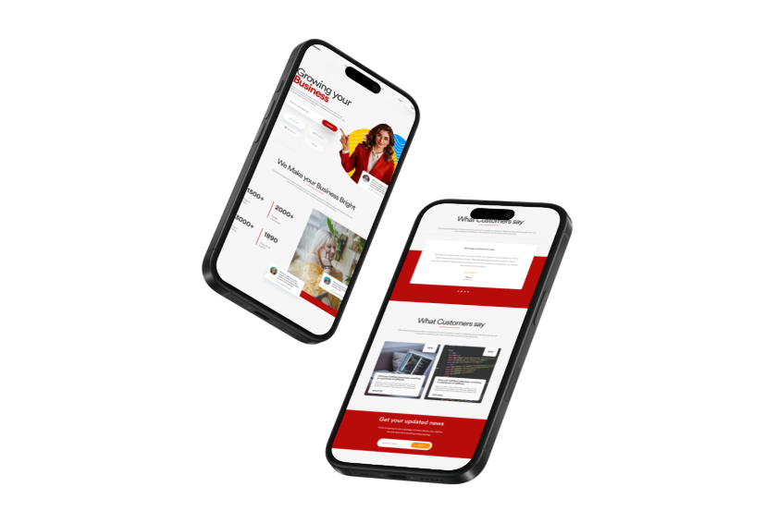
4. **Result** :

Pick your favorite design agency is completed.